European Robotics Week 2017

Technical University in Cluj-Napoca, Romania, is a full member of the European Association of Robotics, with research experience that starts in the ‘70 and is continuing in our days with research in parallel kinematics, Holonic and enhanced reality control, with main applications in medical care and robotic assisted rehabilitation, together with space robotics.
On 14th and 15th of November was organized a workshop and a study visit, with the occasion of the opening of the Headquarter of FANUC Automation Romania, located in Cluj-Napoca.

Theory meets practice
Students at FANUC Automation Romania
Applications Development and Synergies

The workshop was jointly organized by the Technical University Authorized Training Center Siemens PLM and the CESTER- Research Center for Robots Simulation and Testing and the FANUC Cluj-Napoca, under the auspices of the Technical University in Cluj-Napoca Doctoral School.
Within the workshop the following topics were considered:
Day 1
Presentations and Round Table about Robotics at the Technical University.
Presentations and demonstrations regarding FANUC collaborative Robots and CNC control.
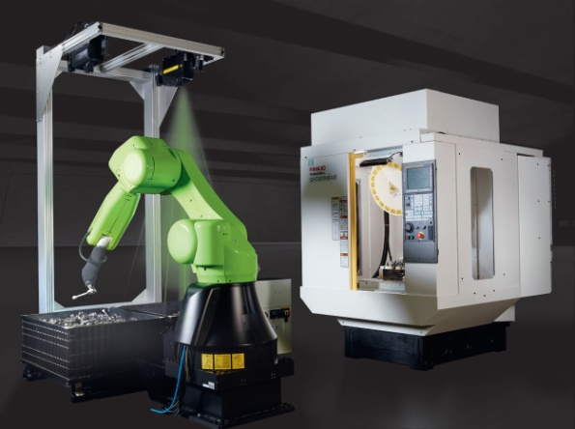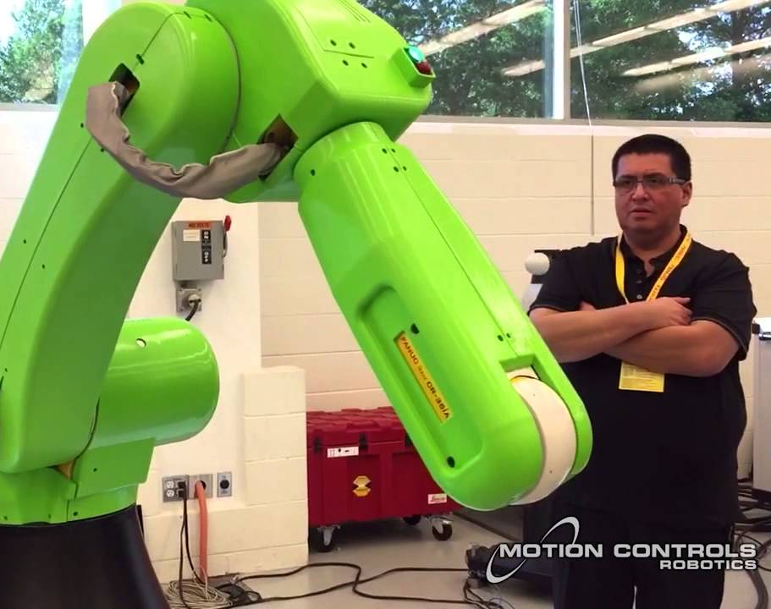
[Courtesy: FANUC, Nov 2017]

Day 2
Showroom demonstration with collaborative robots and manufacturing facilities with ROBODRIL, ROBOSHOT, ROBONANO and ROBOCUT.
Roundtable regarding FANUC Academy
Within the roundtable the following topics were considered:
Training and upskill programs
Study visits at different FANUC locations
Stages and projects in numerical control, logistics and management
Synergic support from the technical University in Cluj-Napoca, Romania; European Supply Chain Echternach Luxembourg and the MIT – Massachusetts Institute of Technology Center for Transportation and Logistics, USA.
Representatives of Technical University and from the FANUC Europe introduced the audience, students, master students, PhD students, academic staff, researchers and representatives from industry, into results in research activity and significant results in which robotics applications are used.
The workshop intends to enhance student’s technical, analytical and leadership skills in regards to Robotics and CNC control, but also supply chain management, logistics, banking and finance sector.

The FANUC Corporation is one of the worldwide leaders in factory automation for CNC control systems, industrial and collaborative robots, together with production machinery (ROBODRILL, ROBOCUT and ROBOSHOT). Since 1956, FANUC is the pioneer in the development of numerically controlled machines in the automation industry.
With more than 259 FANUC subsidiaries worldwide and more than 6,000 employees, FANUC offers a dense network in sales, technical support, research & development, logistics and customer service.
In July 2017, FANUC decide to opens the FANUC Automation Romania, s.r.l. in Cluj-Napoca as the Head Office for Romania and Moldova.
The leading and technical staff is mainly formed by former Technical University in Cluj-Napoca students, exactly from the Industrial Robots specialization.

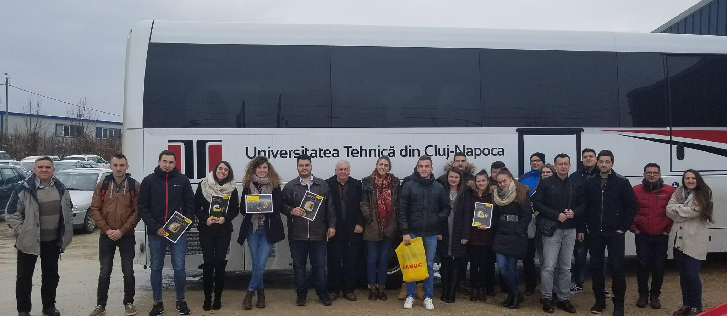
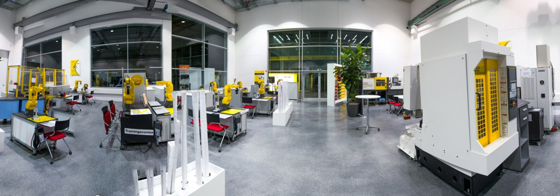
[Courtesy: FANUC, Nov 2017]

