PRESS RELEASE
Trento, 11 September 2018

MUSE FabLab launches the FabLabNet “European School of Makers”

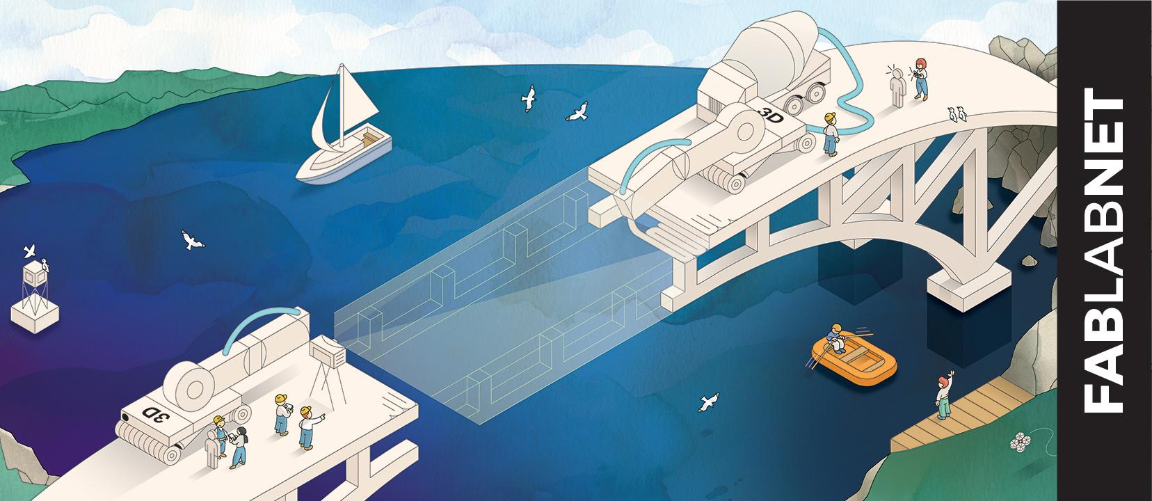

FabLabs are great places for students to learn about STEAM subjects (Science, Technology, Engineering, Arts, and Mathematics). But classrooms (and their teachers) are quite a different audience than the usual fablab users... requiring special programmes, spaces, skills and an engaging attitude.

For this reason MUSE FabLab is proud to offer - in the framework of the FabLabNet European project - two high level training courses dedicated to the relationship between schools and Fablabs:

“Coding@Schools” is targeted to primary and secondary (first cycle) school teachers that want to explore the educational potential of FabLab in teaching digital literacy and STEAM subjects: link to full programme.

“Education programmes in a FabLab” is target to FabLab managers and operators that wish to enhance their collaboration with schools: link to full programme.

The courses are organized in the context of the FabLabNet “European School of Makers” programme: a high profile set of courses specifically designed to share the capacities developed by the nine partners of the FabLabNet project to a wider public of professional, following the project philosophy of making Central Europe more competitive by unlocking the innovation capacity of Fab Labs.

http://www.fablabnet.net/european-school-of-makers/

The participation to all the courses and related educational material are free of charge. Travel and accommodation must be arranged independently by participants. The course will be held in English and Italian.

The official language of the courses will be English, in addition to the local language of the organizer the course.

In case requests will exceed the availability, the organizers reserve the right to select participants on the basis of their CV.

For further information don’t hesitate to contact us: marco.fellin@muse.it

The FabLabNet team

THE PROJECT

Started in 2016, the FabLabNet project aims to make Central Europe more competitive by unlocking the innovation capacity of Fab Labs.

Nine project partners - inspired by and strictly connected to eleven associated partners - share experiences and develop activities to boost their knowledge and capacity, following trends set by the European movement that emphasizes new business models, and marks the difference in current cultural & business world.

The key elements of the project are the joint development of baseline studies to link fablabs to EU Smart Specialization strategies (S3), the joint capacity building in digital manufacturing skills and education programme, the development and test of pilot actions to connect fablabs to the actual industry ecosystem, as well as the realization of activities, tools and events to enhance the relevance of FabLabs for actors of innovation in Central Europe: policy makers, SMEs, and schools.

More info at the project official website.

The project partners:

MUSE – Museo delle Scienze (Italy, Lead Partner)
INNOC – Österreichische Gesellschaft für innovative Computerwissenschaften (Austria)
Fabrikációs Laboratórium Kft (FabLab Budapest) (Hungary)
UnternehmerTUM MakerSpace GmbH (Germany)
Vysoké učení technické, Brno (Czech republic)
Agencja Rozwoju Regionalnego S.A. Bielsko-Biala (Poland)
Muzej in galerije mesta Ljubljane (Slovenia)
Centrum vedecko-technických informácií SR (Slovakia)
FabLab,udruga za promicanje digitalne fabrikacije (Croatia)

FabLabNet is implemented through the Interreg Central Europe Programme co-financed by the ERDF

