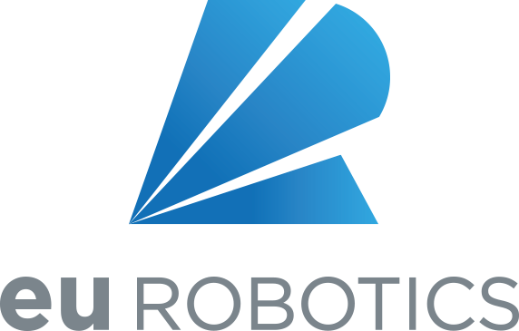

Information for candidates for the Board of Directors of euRobotics, 2019
We are delighted that you are considering supporting euRobotics by serving as a Director. This document is intended to provide some background information and guidance for candidates. You should read all sections carefully.

Introduction
Elections to 8 seats on the Board will be held at the General Assembly (GA) immediately preceding the European Robotics Forum in Bucharest, Romania, on Tuesday 19 March 2019. Your application is invited by the deadline for candidate submissions of 31 January 2019, to allow sufficient time for candidate information to be circulated to Members before the GA. Information on what to submit is provided at the end of this document.
euRobotics is a community of hundreds of robotics stakeholders with Member organisations in Europe from end-users, industry, research and academia. As a community, euRobotics relies on its Members to provide the work and energy which enables it to thrive.
The Board exists to direct and coordinate the activities of euRobotics. Since euRobotics exists to serve its Members’ interests, the Board’s composition is chosen to represent all its Members. If you are elected as a Director, you will therefore represent one of the categories of Members on the Board. Listening to and consolidating the views of other Members in the same category of membership as yourself will be part of the representative role.
This highlights an important distinction between Member representatives who, for example, represent an individual Member organisation at a GA of euRobotics, and Directors, who each represent a category of Members and serve the interests of the whole of euRobotics and its Members. When transacting Board business, you will be expected to represent the wider community, not just your own Member organisation.
A large part of euRobotics’ purpose has been and still is to represent the robotics stakeholder community as the private side of the SPARC Public Private Partnership (PPP). SPARC is the PPP in robotics between euRobotics and the European Commission (EC). During Horizon 2020, euRobotics has coordinated the community to provide input to strategic documents and the Work Programme (WP). In the next year, there is the need to shape euRobotics role and potential partnerships under the upcoming EU programs after Horizon2020, DigitalEurope and HorizonEurope. In addition to the EU related activities euRobotics evolves and develops to provide other opportunities for the community, and value to our Members.
One of the main mechanisms for stakeholder engagement in generating roadmaps and contributions to the WP is the set of activities of the various Topic Groups. It is helpful to the Topic Groups and to the Members for each Director to take an active role in the activities of at least one Topic Group. This enables direct communication and input and feedback between the Board and Topic Groups.
Directors may be asked to take part in specific outreach and external engagement activities. Recently, these have included taking part in European workshops at the European Parliament and Commission consultation processes, speaking at European and international events around the world on behalf of euRobotics and linking with other robotics interest groups in Europe and worldwide. If you, as a director, have a specific skill set, expertise or experience which could help euRobotics, you may be asked to provide specific input to certain activities from time to time. These activities may be internal or external. The Secretariat often solicits help or advice from specific Directors with particular management expertise.
The board is currently made up of 24 Directors including the Vice Presidents (VP’s) and Treasurer, but excluding the President.
The VP roles (one each for Research and Industry) are filled by election from within the Board. The VP’s are typically experienced Board members and senior representatives of the whole Board. Because the VP’s are more likely to be asked to represent euRobotics at external events, and have a larger role in coordinating the Board as a whole, Board members who accept nomination for these roles must consider whether they have the time and availability to fulfil the role. The Treasurer is also elected from the Board, from the Industry side, and is typically a manager or director of another organisation used to dealing with basic financial matters, accounts etc., and also has greater demands on their time.
Since mid-2016, an Executive Team (ExT) of 6 Directors has been in place, comprised of the VP’s and Treasurer and three other Directors. They are expected to contribute as much as one day per week to euRobotics work including, at present, one 1.5 hour conference call meeting each Friday at 11:00 CET. An overview of the time commitment expected of every Director is provided later.
In 2016, to ensure continuity in the Board, the electoral cycle was adjusted. So that one third of the Board is elected each year, on a first in, first out basis. This includes one of the VP’s or Treasurer. This cycle ensures at least two thirds of the board, and two thirds of the ExT, are able to offer their experience and continuity to the board’s business either side of an election. The term of office on the Board is therefore three years, providing you continue to meet the requirements for being a Director.

Overview of euRobotics
euRobotics AISBL (Association Internationale Sans But Lucratif) is an international non-profit association for all stakeholders in European robotics. Our office is based in Brussels, Belgium. We currently have around 230 Member organisations. Our reach is even broader than our membership: at ERF in 2018, there were more than 900 attendees from over 40 countries.
Our objectives are to boost European robotics research, development and innovation and to foster a positive perception of robotics. We aim to:
- strengthen competitiveness and ensure industrial leadership of manufacturers, providers and end-users of robotics technology-based systems and services;
- promote the widest and best uptake of robotics technologies and services for professional and private use;
- promote the excellence of the science base of European robotics.
Our office in Brussels is run by the Secretary General, Dr. Reinhard Lafrenz with a staff of currently 3 people. With some flexibility, given the size of the Secretariat, their roles are events manager, finance officer, operations officer, project manager.
About half of the income is made up of membership fees. This is topped up with income from other sources such as sponsoring of events and income from our involvement as coordinator of the RODIN and partner in DIHNET.EU Coordination Actions under H2020. Just under half of our expenses are staff costs, the remainder being various operating expenses.

Official language
All of euRobotics’ business, including Board meetings and minutes etc., is transacted in English. There are a few exceptions, where Belgian law requires official documents of an AISBL to be in French, in which case English translations are provided.

Expectations of Directors
The broad roles of Directors, the Vice Presidents, the Treasurer and the Executive Team are outlined in the introduction. These roles require a high degree of commitment to fulfil them alongside a Director’s normal employment.
As a guide, in 2018, there were:
- 1 PPP Board meeting
- 3 euRobotics Board meetings and one webex call in addition to the short one held during the General Assembly
- Several EC driven meetings related to specific topics, such as PPP monitoring report or DIHs where some Directors attended, among them meetings with Lucilla Sioli, Director for “Digital Industry”
- additional ExT meetings
Although meetings may be anywhere in Europe, particularly if there’s benefit to meeting at a particular Member’s site, the aim is to hold most of them close to major airports; Brussels is our administrative hub; Munich and Frankfurt airports are convenient transport hubs for many. In addition to that, two meetings were held in cities where Board members are located, one in Paris, one in Bristol.
Please note that, while we generally try to arrange timings so that it is possible to travel in and out on the same day, it is often necessary for some Directors to travel the day before, to attend a morning meeting, especially if travel is by air. This can be particularly onerous when we have Monday morning meetings, since it may require a Director to give up part of their weekend.
Annual time commitment is typically:
 | PPP & Board meetings | TG meetings | ExT Meetings | ExT telecons and work | Other work | TOTAL
VP’s | 8 days | 2 days | 6 days | 13 days | 10 days | 39 days
Treasurer | 8 days | 2 days | 6 days | 13 days | 6 days | 35 days
ExT member | 8 days | 2 days | 6 days | 13 days | 5 days | 34 days
Director | 8 days | 2 days |  |  | 2 days | 12 days

This is a significant time commitment and, while it is not obligatory to attend every meeting and event, a high degree of personal commitment is expected from each Director. The role of Director is an individual one which benefits from continuity and knowledge, so the use of Proxies (other people from a Director’s organisation) is strongly discouraged. In addition, it is considered grounds for removal from the Board if a Director misses two Board meetings in a row without a reasonable excuse. To help Directors attend all Board meetings, they are generally planned up to 6 months in advance, although this is not always possible where the timing of events or EC diaries is not known sufficiently far in advance.
Once a year (more if an ExT member resigns or becomes ineligible to be a Director), two ExT members must be elected from within the Board, one of whom will be a new VP or Treasurer. In general, this will not be a new Director, but one who has served on the Board for at least a year. Given the substantial time commitment involved, please consider whether you would be likely to be able to accept nomination for one of the ExT posts and indicate this on your application form. This is without commitment, but it enables us to assess and understand the sustainability of our structure and working practices.

Expenses and Remuneration
All Directors are allowed to claim expenses for travel and accommodation for Board work, where they have been incurred wholly, exclusively and necessarily for Board work. (Therefore, if a Director attends a Board meeting which happens in the same place as another meeting which they attend as a Member, only additional costs are allowable). A modest budget is calculated for all meetings, and if the total actual expenses exceed the budget, the shortfall is shared equally between all attendees. This ensures it is no more costly for any Director than any other Director to travel on Board business.
Also, especially to ensure Directors from small enterprises are able to play a full and active role, ExT members are currently allowed (although not obliged) to claim for actual time worked up to 8 hours for a full working day (i.e. 8 hours remuneration for 8 or more hours worked), at EC expert remuneration rates. Please note that this is the result of a Board decision ratified by a GA, and is subject to revision at the discretion of the Board and of future GA’s.
Other Directors may be asked to take on a particularly large or time-consuming piece of work for euRobotics, in which case the Board may approve their remuneration at the same rates. The same remuneration is also allowed if the Board asks a Member to provide a person with particular expertise to offer assistance to euRobotics. Note that the uptake of remuneration is relatively low at present: about half of those entitled to claim have chosen not to do so. This is helpful for our budget.

Confidentiality agreement
It is our general policy not to handle confidential information on a routine basis. Members’ confidential information, for example, is generally used entirely within the Secretariat and is not circulated to Directors.
However, there are occasions when it is desirable for a Member organisation or non-member organisation to share confidential information with euRobotics, and for euRobotics to be able to deal with it at ExT or Board level.
On Board business, Directors are acting in their own capacity as Directors of euRobotics. They are not acting as Members’ representatives and confidential information may not be shared with their Member employers or others. While we recognise that this distinction could strain the relationship between a Director’s Member employer and euRobotics, and we therefore keep these instances to a minimum, it is necessary to have formal confidentiality provisions in place to enable this kind of business to be considered in an appropriate manner.
The current Board members have signed individual confidentiality agreements with euRobotics, based on the template attached to this document, and new Directors are expected to do the same. While you are welcome to take legal advice from any source you choose, please note that this is a confidentiality agreement between yourself and euRobotics, not between any employer and euRobotics. Please ensure that you complete the NDA in your own capacity as an individual (not as an employee of any Member or non-member organisation) sign it and return it with your application. If you are not elected, it will be destroyed. If you are elected, it will be counter-signed and become valid from the date of your election.

Timeframe for candidates
Notice of the General Assembly and the associated papers must be sent to the Members not later than four weeks before the GA. The Secretariat requires two weeks to check and compile candidate information for Members. Candidates should therefore return their completed application forms and non-disclosure agreements no later than 31 January 2019 to bod-candidature@eu-robotics.net. Applications received after this time may not be considered or included in the election process.

Enclosures:
Please print, sign, scan and email or post the Non-disclosure Agreement to the Secretariat, for the attention of Dr. Reinhard Lafrenz, Secretary General.
Please complete the application form provided electronically, and return it only I Word format by email to bod-candidature@eu-robotics.net. It may not be possible to process and include printed applications forms in the overall candidate catalogue which is given to the members to prepare for the GA.

Finally
Every Member of euRobotics is a significant stakeholder in European robotics, and every Member’s representative is a senior individual within that Member organisation. The Board tends to be made up of the most senior and accomplished individuals of their type within, and respected by, the whole community. Being a Director provides the opportunity to work alongside experts eminent in their own areas, who all share a common interest in robotics. While it can be demanding, working with this outstanding group of individuals can be enormously satisfying and interesting.
We hope that you go ahead with your application and we look forward to serving with those of you who are elected to represent your peers, and join this Board as Directors.
Rainer Bischoff Stefano Stramigioli
Vice President, Industry Vice President, Research

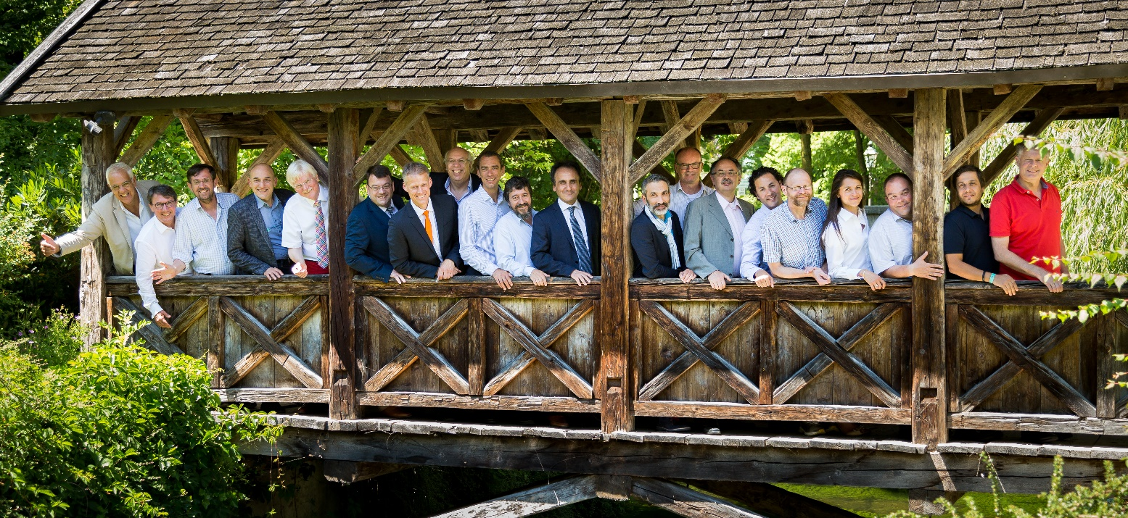
The President and part of the Board of Directors, plus Uwe Haass as a moderator at a Board meeting

NON-DISCLOSURE AGREEMENT

This Agreement is made and entered into between euRobotics AISBL having a place of business at Diamant Building, Boulevard A. Reyers 80,
1030 Brussels, Belgium (hereinafter “euRobotics”); and

having a residence at

(Hereinafter “the Director”)

The Director has agreed to serve on and has been elected to the Board of Directors of euRobotics for a period of up to three (3) years, renewable by any subsequent election. The Director may also be elected or appointed to other positions or to perform functions for euRobotics including without limitation Vice President or Treasurer. To enable the Director to perform any of the aforementioned functions, euRobotics may disclose Confidential Information to the Director. If euRobotics discloses Confidential Information to the Director, then this Agreement shall govern the Director’s obligations in regard to the disclosure and protection of such Confidential Information.

In consideration of the mutual benefits and amenities which may derive from the Director’s service on the Board of Directors of euRobotics, the parties hereby agree as follows:

1. “Confidential Information” is all non-public information possessed by euRobotics that (i) is designated (orally or in writing) as being confidential or proprietary at the time of disclosure or (ii) under the circumstances surrounding disclosure ought to be treated as such by the Director. Confidential Information includes, without limitation, any business ideas, financial information, marketing or promotion plans, strategies, cost information, products, prototypes, inventions, trade secrets, know-how, technology, works, improvements, patent applications, specifications, drawings, and engineering data. Confidential Information also includes information received from others (including without limitation, euRobotics’ members, the European Commission and its agents and representatives, and/or euRobotics’ project partners, customers or suppliers) that is subject to nondisclosure obligations or other confidentiality provisions. Confidential Information also includes similar information developed by the Director for or on behalf of euRobotics while performing his/her duties as a Director.

2. Exclusions from Confidential Information. Confidential Information does not include information that: (i) was generally known to the public at the time disclosed by euRobotics; (ii) became generally known to the public other than through a breach of this Agreement by the Director after the time of disclosure to the Director by euRobotics; (iii) was in the Director’s possession free of any obligation of confidentiality at the time of disclosure to the Director; (iv) was rightfully received by the Director from a third party that was free of any obligation of confidentiality after disclosure by euRobotics to the Director; or (v) was independently developed by the Director without reference to or use of Confidential Information disclosed by euRobotics.

3. All disclosures of Confidential Information by euRobotics to the Director, whether seen, heard, or written, shall be considered Confidential, and any written disclosure should be marked “CONFIDENTIAL” or “PROPRIETARY” as appropriate and shall also be marked to identify the time such writings are first furnished to the Director.
euRobotics AISBL.

Signed: _______________________________________________

Name: ________________________________________________

Title: _________________________________________________

Date: _________________________________________________

4. The Director shall maintain the Confidential Information in confidence for a period of 3 years from the date of the last disclosure of information. During this period, the Director shall not without prior written consent from the board of euRobotics (which may without limitation be in the form of minutes of a decision of the board) divulge such information to any third party. For clarity, Directors may discuss and exchange Confidential Information with other serving Directors or their official proxies who are signatories to a similar Agreement. The Director may use Confidential Information solely for the purposes of his/her duties as a Director or other activities for euRobotics. The Director shall treat such information with the same degree of care as he/she accords to his/her own Confidential Information, but in any event, not less than reasonable care.

5. Confidential Information disclosed hereunder shall remain the property of its owner. By disclosing Confidential Information to the Director, euRobotics does not grant any express or implied rights to the Director to or under any of euRobotics’ or any third party’s patents, know-how, trade secrets, copyrights, or trademarks.

- After receipt of a written request from euRobotics, and in the absence of such a request, no later than 30 days prior to the completion of the confidentiality period set forth in Article 4 above, the Director shall promptly return all documents concerning the Confidential Information to euRobotics, including all copies of any such documents, or certify in writing their destruction, subject to the Director’s right to retain one copy of each such document in his/her files for record purposes only.

- This Agreement shall be governed by and construed in accordance with the laws of Belgium and any action brought to enforce any provision or obligation hereunder shall be brought in a court of competent jurisdiction in Belgium.

- Nothing in this agreement shall be construed in such a way as to establish a contract of employment between euRobotics and the Director or to have the effect of conferring any rights normally associated with employment, to the Director. The Director hereby expressly waives any such rights

- The Director acknowledges that service as a Director of euRobotics is separate and distinct from the Director’s employment for any other party, including without limitation any Member organization of euRobotics. No exception to the provisions in this Agreement is implied by any such employment.

- This Agreement shall automatically terminate 3 years after the date in which the last confidential information was disclosed by euRobotics unless otherwise agreed in writing by both parties. This Agreement may be terminated by either party upon 30 days advance written notice to the other party. Termination of this Agreement shall not extinguish any obligations accrued hereunder at the time of termination; and such obligations shall survive termination to the extent necessary to permit their complete fulfillment or discharge. Assignment of rights, title, and interests shall survive termination of this Agreement.

IN WITNESS WHEREOF, the parties have caused this Agreement to be executed in either one original or two duplicate originals and the effective date of the Agreement shall be determined by the date affixed hereto by the party last signing this Agreement

______________________________________________________
(Full name of the Director)
Signed: _______________________________________________
Date: _________________________________________________

Election to the euRobotics Board of Directors, March 2018 - Form for candidates
Photograph:
here or as an attachment in the mail

<please remove all text in “<>” and fill in as appropriate>
<max. 1 page per candidate – to be sent to>
< bod-candidature@eu-robotics.net >
<Strict Deadline: 31 January 2019>

<Last Name, First Name> <add a picture to the right>

euRobotics AISBL Member: <Name of my organisation (company, institute etc, which is Member of euRobotics AISBL>
Membership Category): <Research, then please indicate: RTO or HES>; <Industry, then please indicate: RM, P, or P-E / and indicate if your company is an SME>; or <Associate Member>
Current position within euRobotics AISBL: < e.g., Director, Coordinator of Topic Group, …. since…>

Current Activities for euRobotics AISBL:
I am currently active /in the Board,…/ on the following issues: / I am active in the Roadmapping process / I am active in the following Topic Group(s) / I would like to help establish / to lead / a Topic Group on <…> <select the appropriate sentence(s)!>:

Position Statement: I consider, as Director, these the most important tasks:

Short CV:

Delete one box as appropriate (not for publication):
I am / am not willing to be elected in future as ExT member/VP/Treasurer

) This Footnote can be deleted! See Bylaws Art. 6.5. Please use the following abbreviations for Subcategories of Membership: Research: RTO: Research Technology Organisations (such as non-university research organisations) HES: Higher Education Establishments (such as Universities) Industry: RM: Robot Manufacturer P: Partner Company (e.g., supplier of robot manufacturers) P-E: Partner Company – End user of robotics

